Carnivals In Somerset
Promotion Project

 |  | Qty | Cost per item | P&P | Total
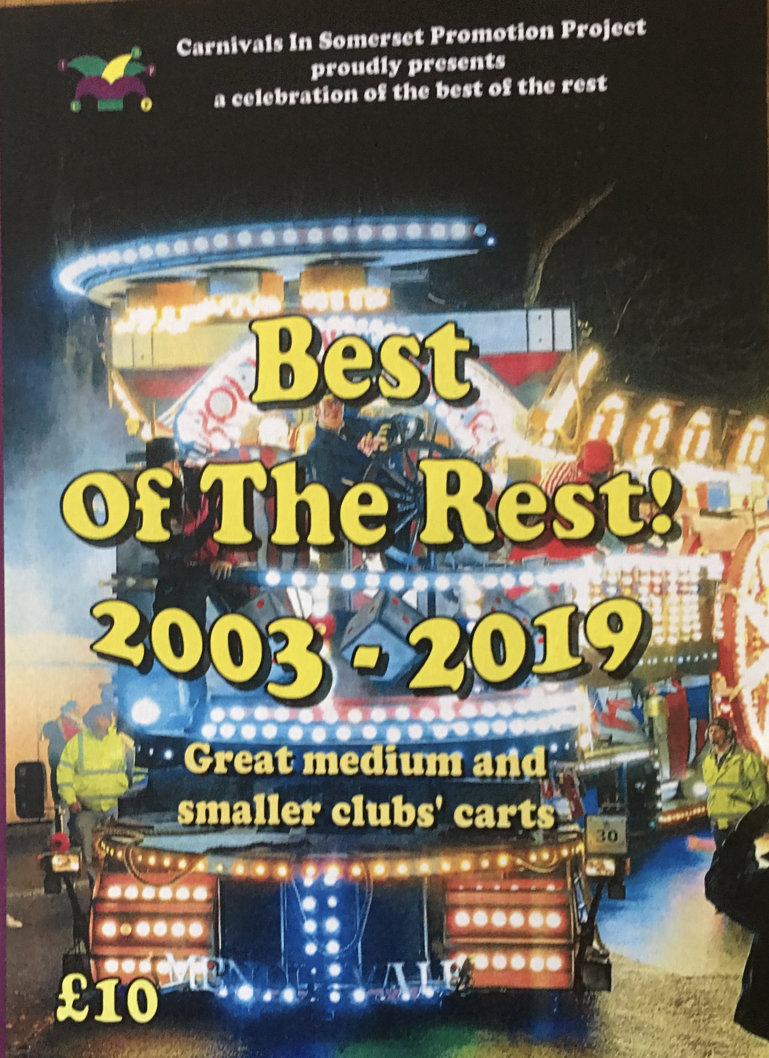 | Best of the Rest DVD |  | £10.00 | £2.00
 | Cirque du Fun DVD |  | £5.00 | £1.50
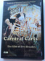 | 5 Decades of Iconic Carnival Carts DVD |  | £10.00 | £2.00
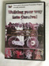 | Walking your way into Carnival DVD.  A history of masquerading. |  | £10.00 | £2.00
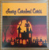 | Scary Carnival Carts DVD |  | £5.00 | £1.50
 | History of Somerset Carnivals |  | £5.00 | £2.00
 | We are the Champions 2003 – 2019  69 cart winners from the Somerset Guy Fawkes Carnivals |  | £10.00 | 2.00
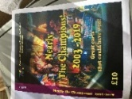 | Nearly the Champions  2003-2019  80 Great carts that could have won! |  | £10.00 | 2.00
 | Have a Cracking Good Carnival Christmas |  | £5.00 | 2.00
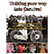 | Walking Your Way Into Carnival |  | £10.00 | 2.00
 |  |  |  | Total

Send form with cheque made payable to CISPP at Highfield House, Galhampton, Yeovil BA22 7AW.
Or for BACS details: Sort code: 20-99-40 a/c: 33777723 email sue@cispp.org.uk

