
Carnival

Exhibition Van
Booking Form
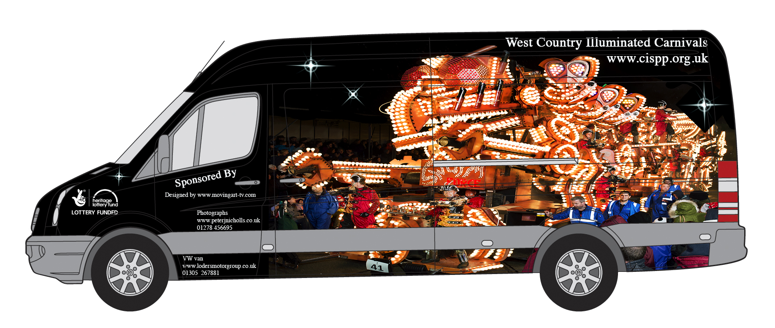
Carnivals In Somerset Promotion Project
www.cispp.org.uk
01963 440472
sue@ cispp.org.uk

The Carnivals In Somerset Promotion Project (CISPP) was formed early in 2009 by a small group of carnival folk who were very concerned that the unique heritage of our Somerset Illuminated Carnivals could be lost in the future unless efforts were made to encourage more people to take part.

CISPP can tell the story of the history of how our carnivals evolved in this part of the world our carnivals beginning with Guy Fawkes and the Gunpowder Plot of 1605.
- We can tell the history of your local carnival covering how people all over England welcomed back the troops from the First World War.
- We can talk about having fun at today’s carnivals covering the safety aspects of why the barriers are there and why we should stay behind them. Who are the people wearing bright yellow jackets are and what they do, when and where we should throw our coins and the consequences of running out into the road to pick up coins that have missed the collection vehicles.
- We can bring costumes for the children to dress up in as well as show an educational presentation designed to introduce children to carnival, how carts are built, how carts get to and from the carnivals and where they are built as well as looking at other world carnivals and looking at how carnival is becoming greener.
- We can take two classes permorning or afternoon session
- In a morning session;.
We will start with a short 10minute introduction. Due to Covid restrictions we have changed our format to having the DVD presentation in the classroom to the whole class (not in the van due to the small area in the van) One class can be watching while the other classis dressing up, after break we can swap over.
- finishing with a 10 minute question and answer session with both classes at the end.
- In an afternoon session starting at 1.30pm, we would have the same format but with just a couple of minutes introduction and without the question and answer session at the end.
We would need an area for dressingup . If there are fewer classes we can tailor the session to suit the school’s needs.

Carnivals In Somerset Promotion Project

Mobile Exhibition Van Booking Form for schools
Name of organisation/ school:

Address:

Contact Name :

Telephone:

Email:

Date Van is required for visit:

How many classes:

Time visit required from ………… am/pm to ……... am/pm

A member of staff must be with the children at all times.

Although we give our time freely, we would appreciate £250 for a morning session or £100 for an afternoon session, to help cover the running costs of keeping the van on the road. We will issue an invoice with BACS details.
Cheques should be made payable to CISPP and given on the day of visit please.

Please return this form to: -
CISPP, Sue Stockman, Highfield House, March Lane, Galhampton, Yeovil, BA22 7AW
Tel: 01963 440472 Email: sue@cispp.org.uk www.cispp.org.uk

